Advantages of PICO lasers over MOPA and FIBER - ideal for Medical applications on Stainless
- The marking time is literally 3 times faster with equal power lasers.
- The mark is absolutely jet black, much darker shade of black than the fiber,, no browning, no fading. You can cover an entire plaque or stainless part with jet black marks, no warping, no deformation of material and no imperfections.
- Readability around cylindrical parts is perfect under all light conditions.
- The market particularly for medical is moving in this direction
- Cosmetically PICO is 100% consistent, no flaws .
- It is a cold marking process so no heat affected zone, which means that the marks don’t pull up carbon or change the molecules in the material the same way they do with fiber and there is never corrosion or rust.
- For medical products it eliminates the need for nitric and citric passivation and the autoclaving that is done in hospitals never wears out the mark. So it saves a lot of money and time at least in the medical industry
- So with products that go under water ocean or outside in harsh environments that are marked with the PICO last forever.
- You can also do very deep engraving much faster ie firearms, stamps, coins with superior finish from all directions.
- Annealing applications are much more palpable
- Engraving applications have much more vertical walls – see photos
- We offer extensive testing in the lab for passivation and salt spray to test the marks-
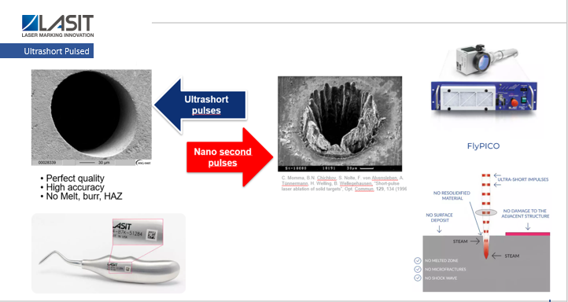

But if you don’t need these characteristics and the volume doesn’t warrant the cost, the fiber and MOPA lasers still do a great job. It has replaced the older YAG technology and Diode technology which required replacing costly bulbs and lots of maintenance and lots of failures. The fiber is rated over 100,000 hours so it was a huge leap in technology.

90% of customers still use fiber, the trend is towards pico especially in medical applications for devices and body implants and when a product requires the utmost cosmetically.
The cost differential to upgrade to the MOPA depending on power is minimal. The MOPA has a variable pulse width so you can also minimize the heat affected zone by varying the pulse width which does less harm to the material. It also mark on plastics nicely so if you had any products with plastic it adds to the range of applications . And you can do bright colors on stainless and titanium should you want to make customer ad specialties or add color to any products.

